Focus Group for App Design

|  |  |  |  |
| --- | --- | --- | --- |
|  | App Design1(Marvel) | App Design 2 ( | App Design 3 |
| Overall Design | 9 | 7 | 8 |
| User Experience | 7 | 8 | 8 |
| Ease of use | 8 | 9 | 8 |
| Usefulness | 8 | 8 | 8 |

App 1

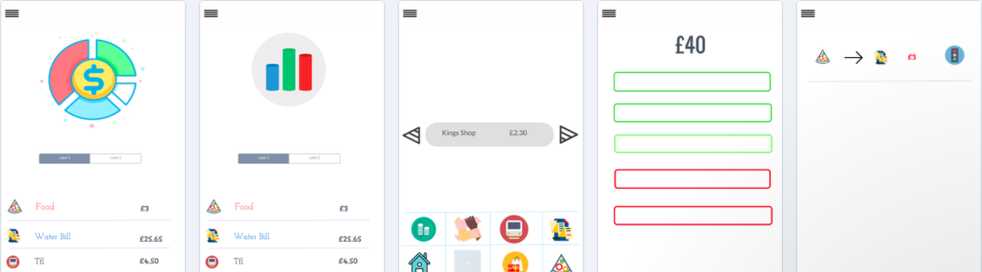

App 2

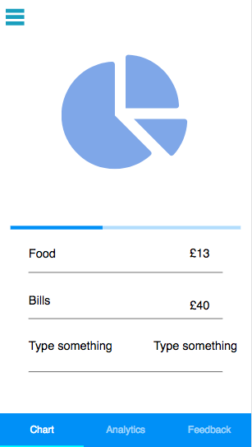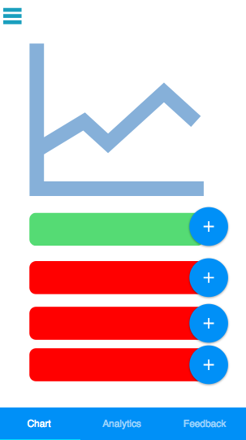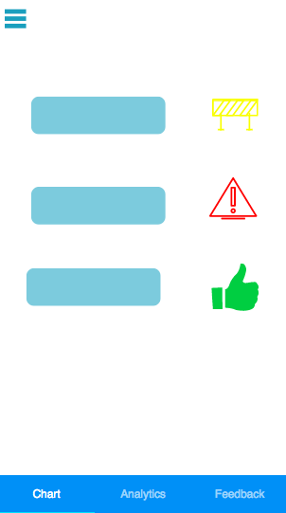

App 3

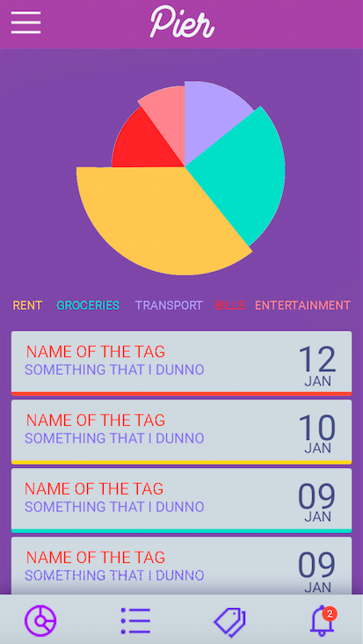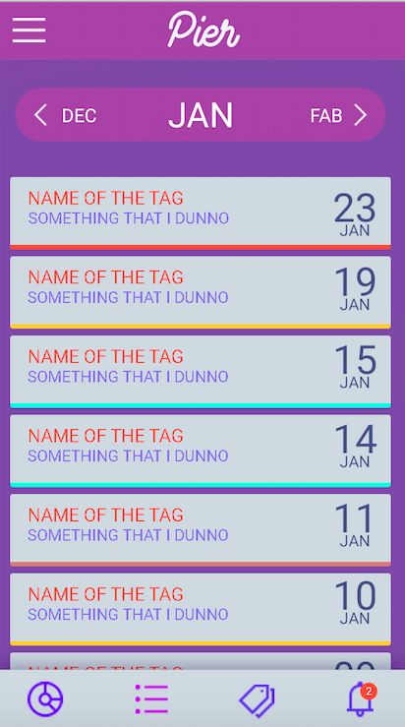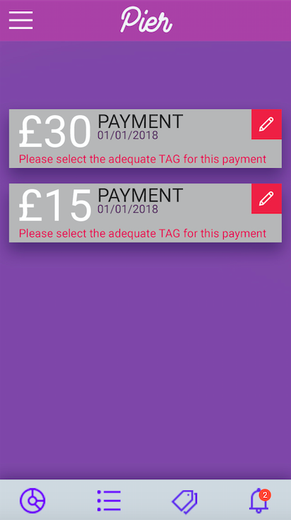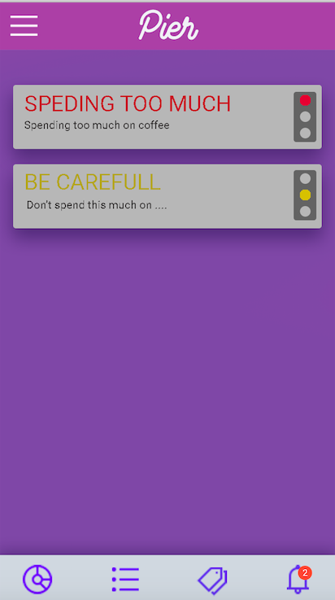

For Each function

**Breakdown –**

Which App has the best breakdown?

- App 3, because its simple and basic

What would you change/add to make it better in your opinion?

* Changing the colour scheme, such as app design1.
* The pie chart could have touch function, so when you touch it, the item pressed will show what you have spent on

**Data Analytics -**

Which App has the Data Analytics?

* App 2
* The calendar layout is really good

What would you change/add to make it better in your opinion?

- Changing

**Tags-**

Which App has the best tags?

App3

What would you change/add to make it better in your opinion?

Make it look more friendly

**Alerts**

Which App has the best Alerts?

App 3

What would you change/add to make it better in your opinion?

A more appealing graphic

**Input Method**

Method 1 – Leave to side bar

Method 2 – Put in tab- definitely tab

**Any other comments/ Suggestions**

Maybe use a speedometer to track saving